Windsor Geometry Final Exam Review – Spring 2015

Transformations Review
Name the transformation that maps the unshaded arrow (preimage) onto the shaded arrow (image).

14. | 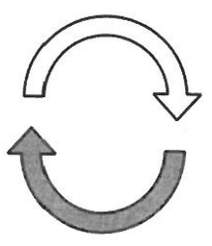 | 15. | 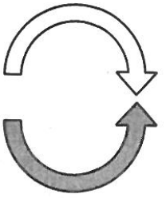 | 16. | 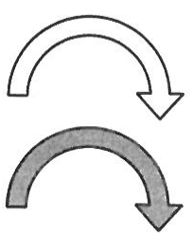

Decide whether the transformation is rigid. If it is, name the transformation. (Preimages are unshaded; images are shaded.)

17. | 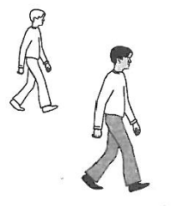 | 18. | 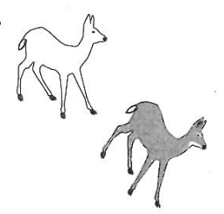 | 19. | 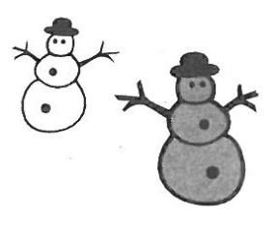

Use the graph of the transformation below. ABCDEF is the preimage.

20. | Name and describe the transformation. | 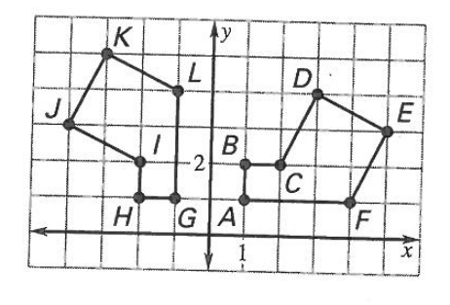
21. | Name the image of 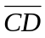.
22. | Name the preimage of 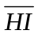.
23. | Name the coordinates of the preimage of point J.
24. | Show the EF and KL are equal by using the distance formula.

Draw the reflection of the figure in the line l.

25. | 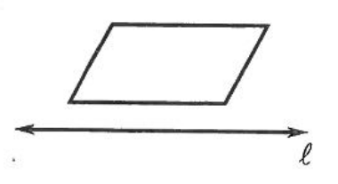 | 26. | 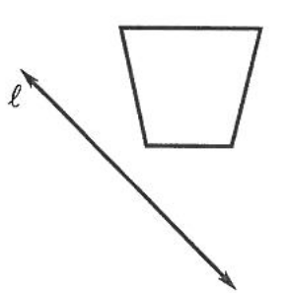

Find the coordinated of the reflection without using a coordinate plane. Then check your answer by plotting the image and preimage on a coordinate plane.

27. | 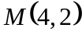 is reflected in the x-axis | 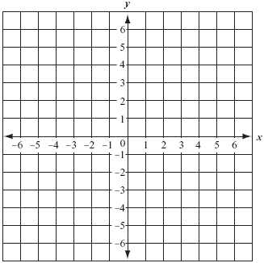
28. | 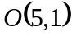 is reflected in the y-axis
29. | 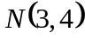 is reflected in the line y = 1
30. | 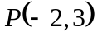 is reflected in the line x = -3

Use the diagram at the right to name the image of Segment 1 after the reflection.

31. | Reflection in the x-axis | 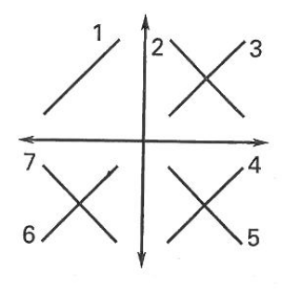
32. | Reflection in the y-axis
33. | Reflection in the line y = x
34. | Reflection in the line y = -x
35. | Reflection in the y-axis followed by a reflection in the x-axis
36. | Reflection in the x-axis followed by a reflection in the y-axis

State the segment or triangle that represents the image.

37. | 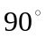clockwise rotation of 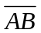about P. | 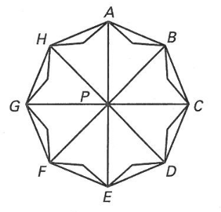
38. | clockwise rotation of 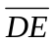about P.
39. | counterclockwise rotation of 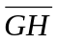about P.
40. | 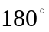clockwise rotation of 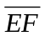about P.
41. | clockwise rotation of 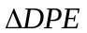about P.
42. | 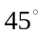counterclockwise rotation of 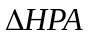about P.

Name the coordinates of the vertices of the image after a clockwise rotation of the given number of degrees about the origin.

44. |  | 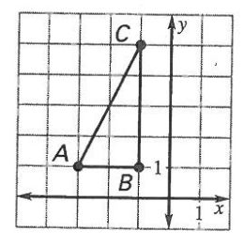 | 45. |  | 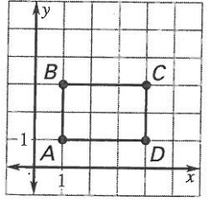

Match the graph with the description of the translation.

A. | 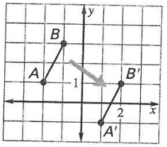 | B. | 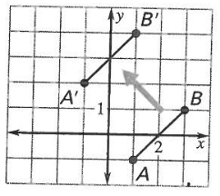 | C. | 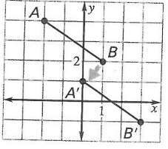
46. | 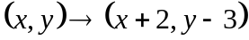 | 47. | 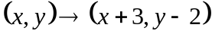 | 48. | 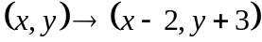

Describe the translation using (a) coordinate notation and (b) a vector in component form.

49. | 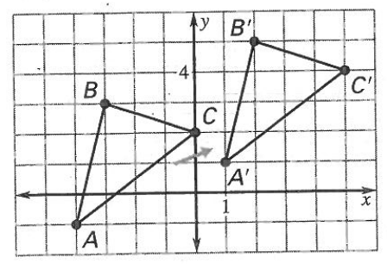 | 50. | 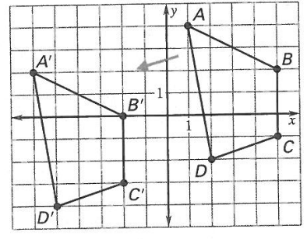

Consider the translation that is defined by the coordinate notation 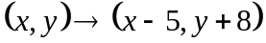.

51. | What is the image of 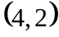?
52. | What is the image of 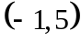?
53. | What is the preimage of 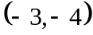?
54. | What is the preimage of 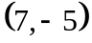?
Use a straightedge and the graph on the right to translate by the given vector.

55. | 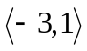 | 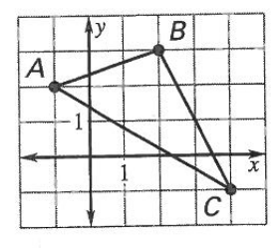
56. | 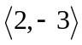

Identify the dilation and find its scale factor.

57. | 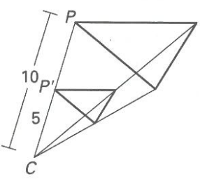 | 58. | 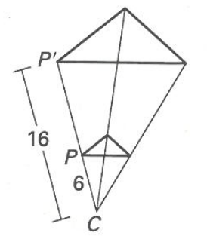 | 59. | 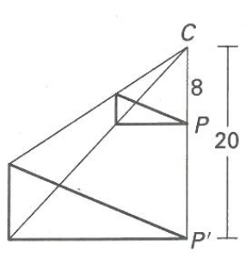

The larger polygon is an enlargement of the smaller polygon. What is the scale factor? Solve for the variables.

60. | 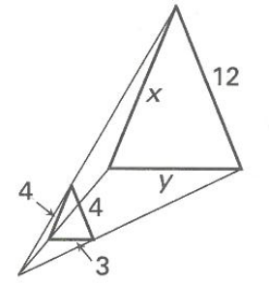 | 61. | 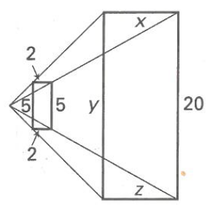 | 62. | 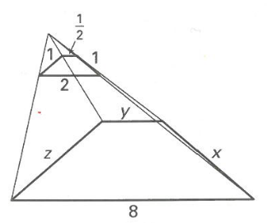
Use the origin as the center of the dilation and the given scale factor to find the coordinates of the vertices of the image of the polygon.

63. | 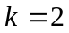 | 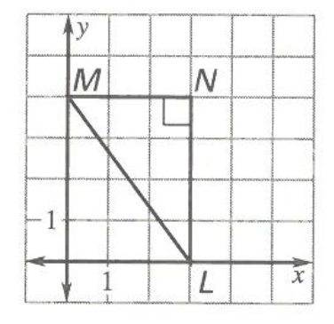 | 64. | 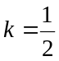 | 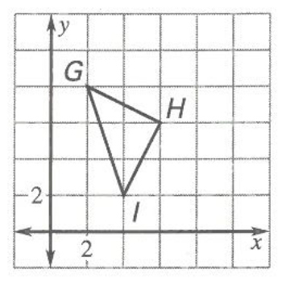

Polygons Review
65. If 2 polygons are similar, then the corresponding angles are_____ and the corresponding sides are ______.
66. If approximately 6 out of every 7 dentists in Parker recommend chewing sugar-free gum, and there are 43 dentists in Parker, about how many of them recommend chewing sugar-free gum?
67. A building casts a 103-foot shadow at the same time that a 32-foot flagpole casts as 34.5-foot shadow. How tall is the building? (Round your answer to the nearest tenth.)
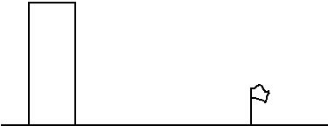

68. Solve for x: 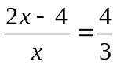

69. A triangle has sides in a ratio of 2:3:5. If the perimeter is 60 cm, what are the lengths of the sides?
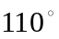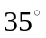
B
a
17
20
13
10
70. Triangle ABC ~ XYZ, find the lengths of a and b and measures of the 4 missing angles.
A
C
Y
Z
b
X

71. Find the ratio of 5 meters to 200 cm.

72. Find the ratio of 2 hours to 50 minutes.

73. Find all possible values for x.
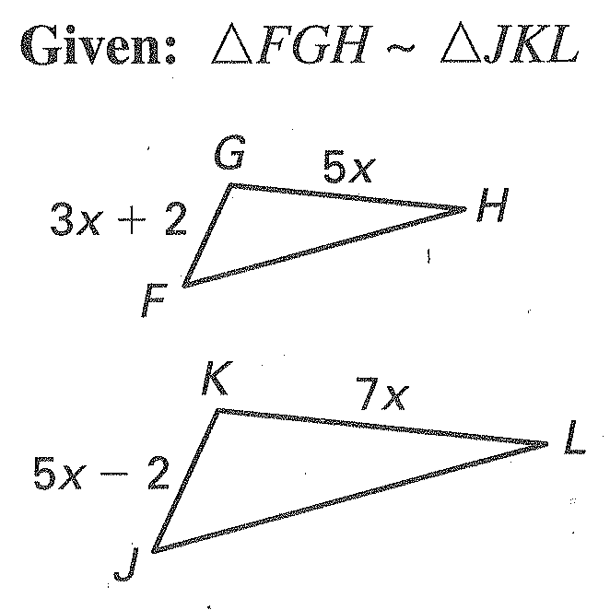

81. If 1 clank = 7 bops and 2 bops = 1 fig, how many clanks are equal to 28 figs?

82. At a certain school, the ratio of teachers to students is 1:8. Which of the following could be the total
number of teachers and students at the school?

A. 16 B. 18
C. 24 D. 37
E. 42

83. A bakery uses a special flour mixture that contains corn, wheat, and rye in the ratio of 3:5:2. If a bag of
the mixture contains 5 pounds of rye, how many pounds of wheat and corn does it contain?

84. A basketball team had a ratio of wins to losses of 3:1. After winning six games in a row, the team’s
ratio of wins to losses was 5:1. How many games had the team won before it won the six games?

85. On a map, 2 centimeters represents 7 kilometers. A square on a map with a perimeter of 8 centimeters
represents a region with what area?

86. The area of a rectangle is 108 cm². The ratio of the width to the length is 3:4. Find the length and the
width. SHOW ALL WORK!

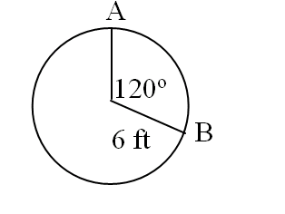
101. Find the arc length and area of the sector shown.

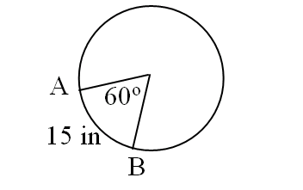
102. Find the circumference of the circle.

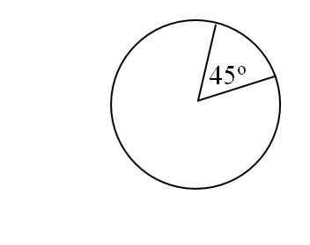
103. Find the radius of the circle if the area of the sector shown is 20π cm².

104. Find the sum of the interior angles of a regular 13-gon.

105. Find the area of a regular hexagon with sides of length 15 cm.

106. Find the area of the shaded region if the area of the square is 64.

Find the value of x. Figures are not to scale.
(5x – 12)º
(4x + 45)º
2xº
(x + 24)º
(3x + 3)º
(3x + 1)º
(12x +6)º
(4x – 3)º
(10x + 8)º
107. 108.

109. Find the area of the square.
8

112. Find the area of the shaded 113. Find the radius if the area of the shaded
region. region is 20.
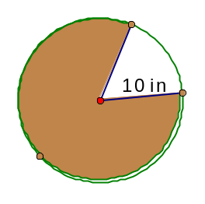
60◦
45º

114. Find each interior angle of a 20-gon.

115. Find the area of this regular octagon with a side length of 8 meters. Round your
answer to the nearest tenth.
8 m

116. Find the area of a regular hexagon with radius of 6 inches. Answer must be exact!

6

Quadratics Review

117. Solve by factoring:

a) 2x² + 5x – 18 = 0 b) x² – 9 = 0 c) 5x² – 35x = - 60

118. Solve using the quadratic formula:

- 5x² + 7x + 2 = 0 b) 2x² – 3x = 8

Distance and Midpoint Review

119. Find the midpoint of 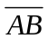 given A(-1, 7) and B(3, -3).

120. Find the midpoint of 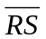 given R(2, 6) and S(-1, 1).

Find the distance between each pair of points.

121. (9, 3) and (-2, 4) 122. (2, -1) and (4, -8)

